**Imeruli khachapuri (Georgian cheese filled bread)**

Prep Time20minutes mins

Cook Time25minutes mins

**Ingredients**

* 3 cups plain flour
* 1 ½ teaspoon instant yeast
* 1 teaspoon salt
* 1 teaspoon sugar
* 1 cup milk gently warmed (may need a splash more)
* 2 cups chopped greens : spinach, mibuna
* ½ cup chopped herbs (parsley, oregano, thyme and a little rosemary)
* 1 egg
* 2 ½ cup mozzarella grated
* 1 cup feta crumbled
* ½ tablespoon butter

**Instructions**

* **Mix Dough Ingredients:** Combine flour, yeast, salt, and sugar in a bowl. Stir in warm milk until the dough comes together. Add a bit more milk if the dough is too dry; it should be soft but not sticky.
* **Knead Dough:** Knead for about 5 minutes, either by hand on a clean surface or using a stand mixer with a dough hook for 2-3 minutes.
* **Let Dough Rise:** Coat a medium-large bowl with a little oil. Place the dough in the bowl, turn it to coat with oil, cover with a cloth or plastic wrap, and let it rise in a warm place for about 90 minutes, or until doubled in size.
* **Prepare Greens:** Cook washed and chopped greens in a pan for about 5 minutes until wilted. Add herbs and cook for an additional 1-2 minutes. Remove from heat and let cool.
* **Mix Filling:** Combine crumbled feta, grated mozzarella, and egg. Stir in the cooled greens. Divide the mixture into two balls.

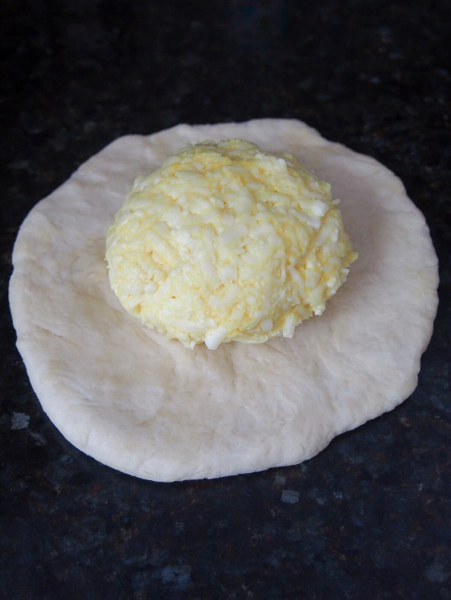

* **Shape Dough:** Once the dough has risen, punch it down and divide it into two pieces. Set one piece aside.
* **Flatten Dough:** Flatten one piece of dough into a 6-inch (15 cm) circle. Place a cheese ball in the center.
* **Seal Filling:** Fold the dough over the cheese, pinching the edges to seal and cover the filling completely.
* **Flatten and Turn:** Flatten the sealed dough ball slightly, pressing to smooth it out, then turn it over.
* **Roll Out:** Flatten the dough further with your hands and a rolling pin into a 9-10 inch (23-25 cm) circle. Seal any holes with extra dough and a bit of water if needed.
* **Repeat:** Do the same with the second piece of dough and filling.
* **Cook:** Heat a skillet over medium heat. Cook one bread for 3-4 minutes on each side until brown, brushing each side with butter as it cooks. Transfer to a plate.
* **Serve:** Repeat with the second bread, then slice and serve warm.

