*お好み焼き Okonomiyake “As you like it” Omelette.*

*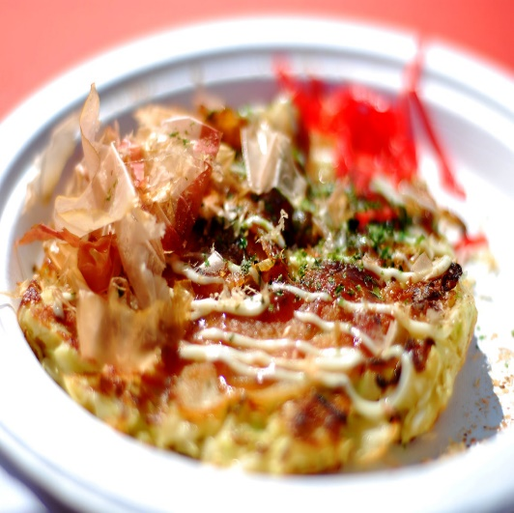*

*Ingredients*

1 cup Plain flour

½ tsp Baking powder

1 tsp Salt

200ml Water or stock

2 Eggs

4 cups Green cabbage (Finely sliced)

4 Spring onion (Chopped into rings)

½ cup veg Oil (For frying)

*Topping*:

Okonomiyaki sauce: equal parts tomato sauce, oyster sauce plus 2 tsp Worcestershire sauce

Kewpie Mayo

Furikake (Nori sheets)

Sushi ginger

*Method*

* To begin, add all your dry ingredients to a bowl and give it a quick whisk so everything is evenly distributed. Then do the same with wet ingredients by whisking your egg and water together.
* Pour your egg mixture into your dry ingredients and stir to combine. It doesn't have to be perfectly smooth. You're better off having a few lumps of flour than overmixing your batter.
* Finely shave the cabbage and chop up your spring onion into rings.
* Add all your vegetables to the pancake mix and stir until everything is thoroughly coated in batter. You want the batter to be majority filling that is just held together with batter.
* Heat around 1 tbsp of a neutral oil (veg, canola, rice bran etc) in a medium frypan over a medium heat. Drop in around 1/3 cup of batter, depending on the size you want. You can make mini ones, or opt for one large one and cut it up. Your batter should only be a couple of centimetres thick, so spread it out if you need to.
* Cook on one side for 3-5 minutes or until golden and crispy on the underside. Carefully flip it over, and cook for another 3-5 minutes on the other side. It should be thoroughly cooked in the middle after this time
* Transfer it to a plate and smother it with Okonomiyaki sauce, Kewpie mayo, Furikake and more spring onions. Cut into portions and serve.