Broad Bean Pesto (Pizza Topping)
Ingredients
- 2 handfuls of broad bean tips (leafy part)
- 1 cup of green herbs (parsley here, could also Basil/Rocket or carrot tops)
- 2 cloves of garlic
- ½ lemon zested (1 tsp)
- pinch of salt (1/2 tsp)
- ½ cup grated parmesan
- ½ cup sunflower seeds
Method
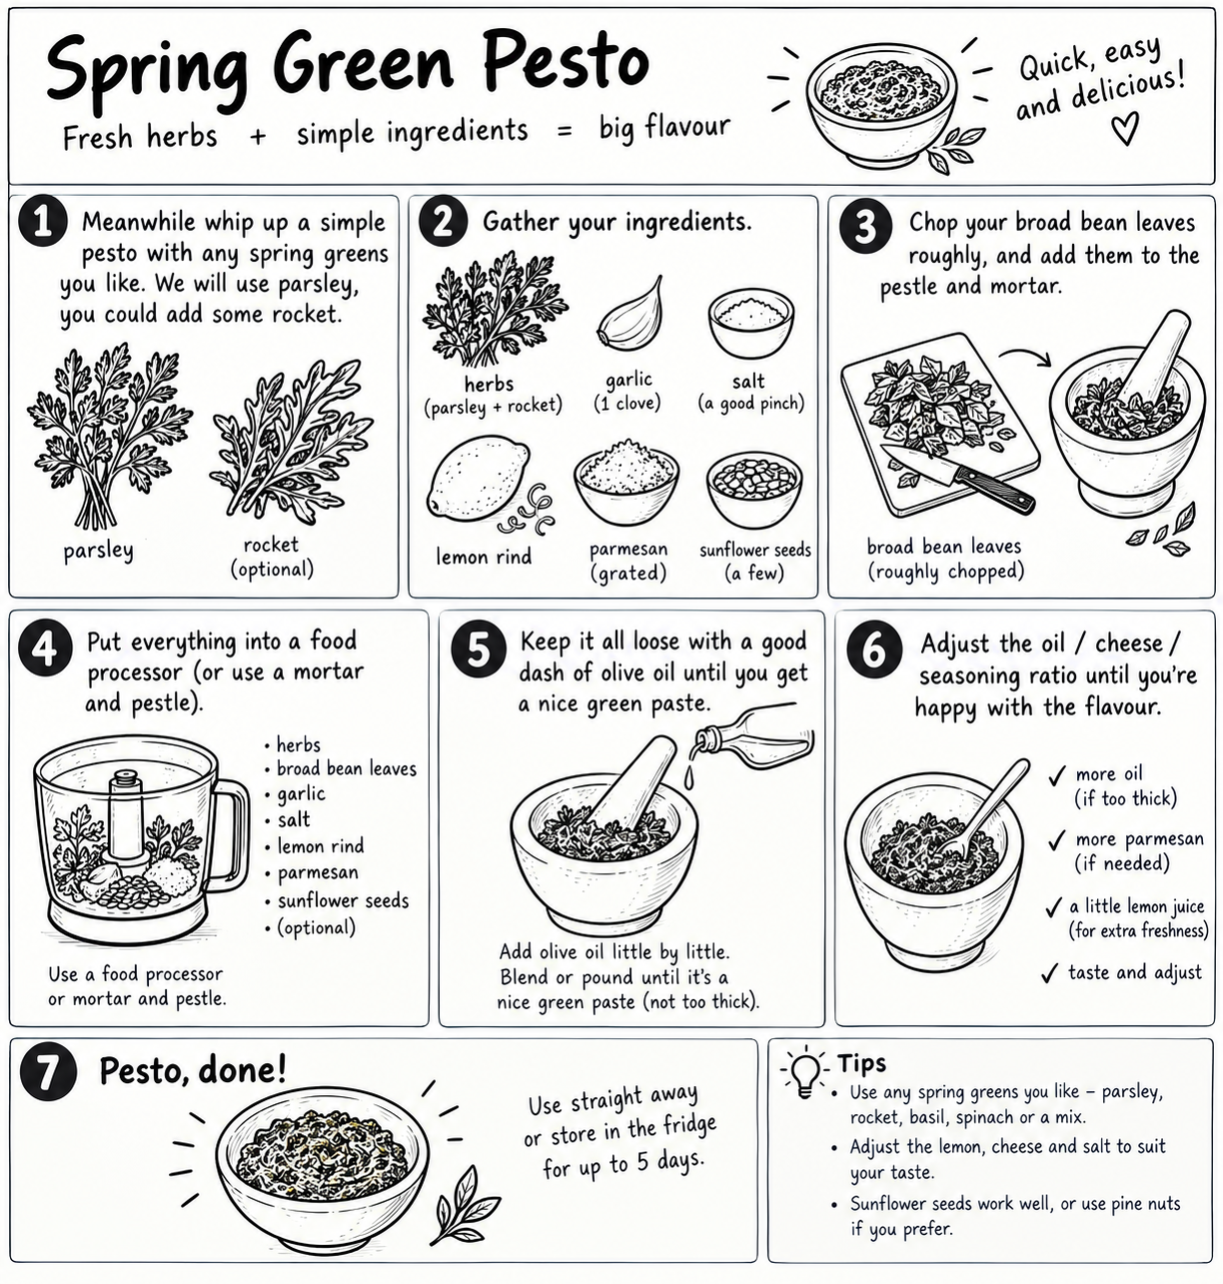ENJOY!

